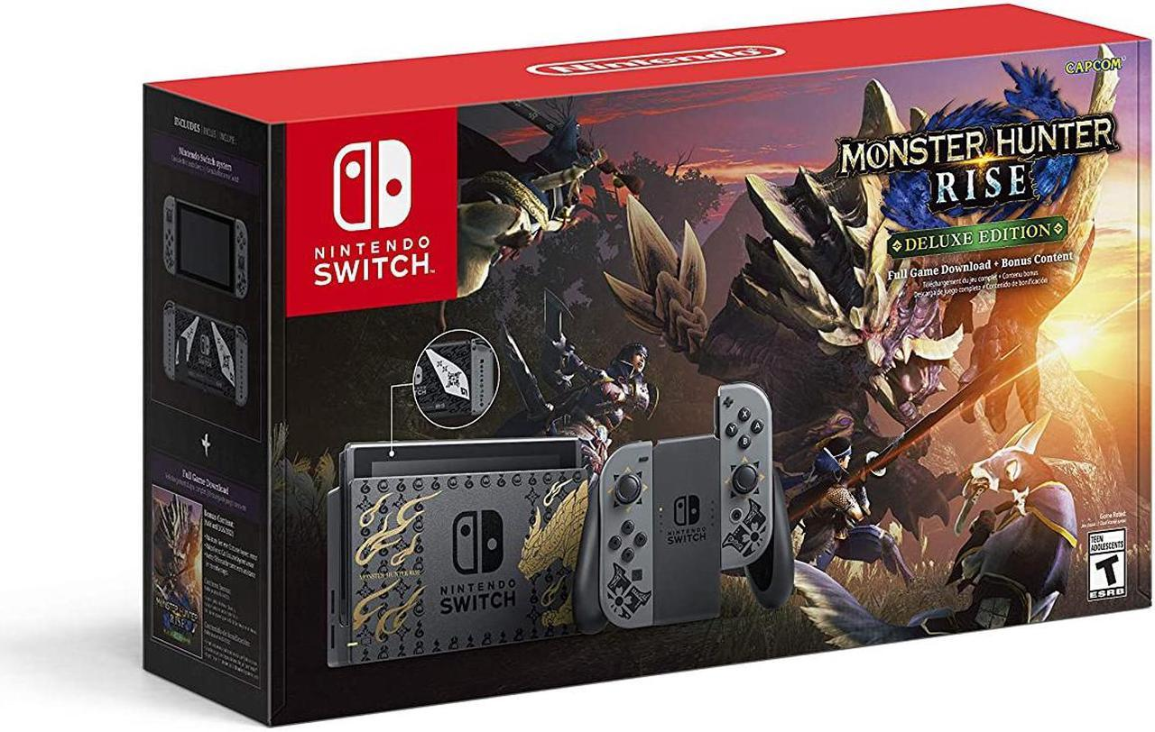

*Monster Hunter Rise:*

1️. **Fast-Paced Combat & Vertical Movement**

* **Wirebug system** allows aerial attacks, wall-running, and fast dodges.
* **Mounted combat** with Palamutes for greater mobility.

2️. **New & Returning Monsters**

* Features the **flagship monster Magnamalo** and classic creatures like **Rathalos, Tigrex, and Mizutsune**.
* **Sunbreak Expansion** adds even more powerful **Master Rank** monsters.

3️. **The Rampage Mode**

* A **horde-style defense mission** where hunters protect Kamura Village from waves of monsters using traps and reinforcements.

4️. **Multiplayer & Co-op Hunting**

* **4-player online co-op** allows teams to take down massive monsters together.
* **Seamless matchmaking** for drop-in multiplayer action.

5️. **Deep Weapon & Armor Customization**

* **14 weapon types** with unique playstyles.
* **Craft and upgrade gear** using materials from defeated monsters.